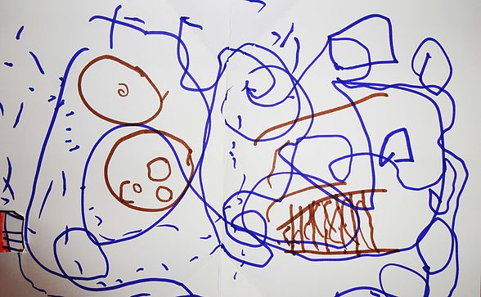
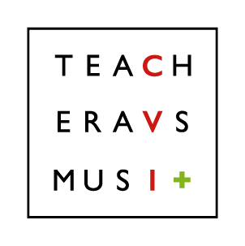

“My home: stairs, people, and windows”
Drawing by S.H., a five year old girl with CVI.

http://www.teachcvi.net
Copyright © 2017 by the TeachCVI project (Erasmus+ project)
Cerebral Visual Impairment

TEACH CVI materials for training of teachers
Chapter III – The child’s literacy profile

- Material produced by the TEACH CVI project members
- This publication was supported by the Erasmus+ Programme of the European Commission
- Please note that information provided into this folder for teachers training is not exhaustive
- This publication reflects the views of the authors. Therefore, the Commission cannot be held responsible for any use of the information contained herein.

Chapter III:
The child’s literacy profile

LITERACY PROFILE FOR CHILDREN WITH CEREBRAL VISUAL IMPAIRMENT

Part 11. Access to literacy…………………………………………………...4
Part 12. Literacy profile for children with CVI…………………………...…6
- Stage of literacy development.............................................................6
- Foundation for literacy: Expressing and recevinng information….…..8
- My literacy profile………………………………………………………….10

Part 11. Access to literacy
Literacy is something that most often exists in and supports social relationships, when people communicate with each other in different ways. Children meet literacy and learn its social value very early life, e.g. when listening to bedtime stories, drawing pictures for granny or recognizing environmental print.
Literacy is not only about the ability to read and write. It is an act of liberation and empowerment, of taking a role as an active citizen in society. Literacy is “reading the word and the world”.
The Convention on the Rights of the Child states:

“The child shall have the right to freedom of expression; this right shall include freedom to seek, receive and impart information and ideas of all kinds, regardless of frontiers, either orally, in writing or in print, in the form of art, or through any other media of the child’s choice.”

Children with CVI, with and without additional disabilities, have specific and diverse needs when it comes to literacy exposure and experiences. Many lack opportunities to engage naturally in incidental learning. Professionals from different fields share the responsibility to support children with CVI to gain access to literacy and give them an opportunity to reach their best potential.

The literacy profile is a way of gathering information that supports a child’s access to literacy based on their visual functioning and educational needs.
The profile contains information about:

- The child’s stage of literacy development
- Strategies that support the child’s access to literacy

The TeachCVI project supports the concept of literacy as a continuum starting at birth.

Stages of Literacy Development | Examples | Age
Building a Foundation for Literacy Development | E.g. chew on books, enjoy rhymes, attend to pictures, understand that an object can be a symbol for an activity, etc. | 0 – 2
Early Emergent Literacy | Pretend reading, listen to stories, recite and fill in phrases in a story, scribble, draw, etc. | 2 – 4
Emergent Literacy | Understand that text and pictures convey meaning, begin to recognise familiar environmental print and their name, may write some letters, etc. | 4 – 5
Developing Literacy | Awareness that words are made of different sounds, decode words, write simple sentences, etc. | 6 – 7
Early Independent Literacy | Shift from “learn to read” to “read to learn”, read independently for a longer time, write own ideas and observations, etc. | 8 – 9
Independent Literacy | Read confidently and independently in multiple modes of text, written work is organised, coherent and easily understood, etc. | 10 – 11
Expanding Literacy | Reading for acquisition of knowledge, analyse and think critically about ideas presented in text, write for a variety of reasons and in diverse modes, etc. | 11+

PART 12. LITERACY PROFILE FOR CHILDREN WITH CVI
Name: | Date:
School/Kindergarden: | Filled in by:

- Stage of literacy development.
Stage of Literacy Development | Check stage | Observations  Examples of activities
Building a Foundation for Literacy Development
Early Emergent Literacy

Emergent Literacy

Developing Literacy

Early Independent Literacy

Independent Literacy

Expanding Literacy

- Foundation for literacy: Expressing and receiving information
I express myself through… |  | Ways others can communicate with me…
Natural body language and facial expression  (e.g. breathing, smiling, crying, yawning) |  |  | Natural body language and facial expression  (e.g. relaxed posture, smiling, excited breathing)
Vocalisation/sounds  (e.g. sighing, laughing, screaming) |  |  | Vocalisation/sounds  (e.g. making sounds of activities like “yum-yum” for food)
Gestures  (e.g. pointing, waving goodbye, shaking head for refusal) |  |  | Gestures  (e.g. pointing, waving goodbye, shaking head for refusal)
Real objects  (e.g. looking or pointing at, picking up a cup to express thirst) |  |  | Real objects  (e.g. giving the child his spoon to eat with, make object books from self-experienced activities)
Tangible symbols  (e.g. looking at, picking up an object that represents an activity) |  |  | Tangible symbols  (e.g. presenting the child an object that represents an activity)
Pictures  (e.g. looking or pointing at, picking up a picture to indicate a need, choice, comment) |  |  | Pictures  (e.g. presenting the child a picture to indicate an activity, pictures that illustrate a word)
Manual or tactile signs  (e.g. signing “swing” to express a wish to go out and swing, sign for tired) |  |  | Manual or tactile signs  (e.g. signing “swing” to indicate activity, sign “sleep” to indicate lunch nap)
Spoken language  (e.g. using spoken words to make comments, express needs; includes electronic speech devices) |  |  | Spoken language  (e.g. using spoken words to engage the child)
Written language  (e.g. handwriting or typewriting in print, Braille, etc) |  |  | Written language  (e.g. handwriting or typewriting in print, Braille, etc.)
Observations, examples, notes
 | Expressive communication | Receptive Communication
Natural body language and facial expression

Vocalisation/sounds

Gestures

Real objects

Tangible symbols

Pictures

Manual or tactile signs

Spoken language

Written language

C. My literacy profile

My name is: |  |  | Optional: a photo of me
Things I like to talk about:

Activities I like to do:

My favourite toys:

My favourite colour(s):

My best sense(s) for learning:
Vision
Hearing
Touch
Movement
Smell/taste
My personal aids and equipment:
Glasses for near vision tasks for distance vision tasks
Hearing aid(s) left right
Orthotic devices:
Other:

My best body position to access visual tasks (e.g. sitting, standing, lying on stomach/back/side, moving around etc.):

My preferred light conditions:
Spotlight for near vision tasks
Daylight/bright light
Dimmed light
Other:
Conditions that support my visual attention:
Quiet environment
Plain background
Favourite colour(s)
Good contrasts
Well-known materials/tasks
Elements of movement/shiny objects
Time to respond
One sense at a time
Other:

How to present a task for me
I can look and listen to instructions at the same time
I cannot look and listen to instructions at the same time
Optimal distance to present a task for me:

My best visual field to view a target:
Side: on my left straight ahead on my right
Height: above eye level at eye level below eye level

I can see best when the target is
Moving Still

Maximal number of targets presented at a time:
One Two Three or more Well spaced

Maximal number of colours at a time:
One Two Three or more

Best background to present visual target (eg. colour, material, decluttered):
The use of real objects alongside a picture or text supports my
understanding
Present object before I attend to a picture or text
Present object at the same time as picture or text
Present object after I attend to a picture or text
My object and pictures specification:
 | Optimal size | Coloured |  | Black&white
Objects

Photographs

Simple pictures

Complex pictures

Drawings

Others:

My print specification:
Font:
Font size:
Bold text Plain text
Spacing:  Between lines  Between words | Between letters  Between numbers
Braille
Other:

My working space
Position in the classroom:
Equipment and adaptations:
Spotlight
CCTV/video magnifier
Adapted keyboard
Speech synthesis
Simple, clutter free working environment (Tri-fold board, screen, reading
stand)
Tidy desk
Sloped board or table Angle:
Plain table or tray top Colour:
Colour coding of materials and/or personal things
Bright coloured pens, exercise books and rulers
Other:

This is how my working space should look like (photo):

Focus and motivation:
Length of time I can focus on visual tasks:
How I show that I am motivated:
My best motivator or reward:
How I show that I am bored:

How I show that I am getting tired:

Things I like to do during breaks or after visual activities:

Notes:

Freire, P., & Macedo, D. (1987). Literacy: Reading the word and world. South Hadley, MA: Bergin & Garvey.
United Nations Convention on the Rights of the Child (1990). Article 13: Freedom of expression. Retrieved from http://www.ohchr.org/EN/ProfessionalInterest/Pages/ CRC.aspx
Adapted from http://literacy.nationaldb.org/index.php/literacy-development-continuum/
Age ranges indicate when one would expect children without disabilities to be engaged in the activities and behaviours listed and are provided for general reference only.
Adapted from http://literacy.nationaldb.org/index.php/literacy-development-continuum/

